REVIEW OF LITERATURE
During teenage years and early adulthood, students are strongly influenced by the people around them. Students spend a lot of time with their peers, so they have a big impact on their academic, personal, and career decisions.
The previous researches has consistently shown that peer influence can shape students’ choices.
A study performed by Francis Kinyua Nderitu, Enos Barasa Mukadi, and Prisca Tarus - Kiptoo from the Department of Psychology, Counselling and Educational Foundations at Laikipia University examined whether peer pressure has influence on career decision making self - efficacy among students in public secondary schools in kiambu county, Kenya. The study targeted Form Three students and career teachers across 285 public secondary schools in the county. The target population consisted of 29,682 Form Three students (14,361 boys and 15,321 girls) and 285 career teachers.
It was concluded that peer pressure has statistically significant influence on career decision making self-efficacy among students in public secondary schools.

Hassan, Esere, and Abdul kareem (2024) studied the effect of peer pressure on career aspirations among secondary school students in Nigeria. The study found that students often copy their peers’ lifestyles and choices. This imitation strongly influences their career decisions specially when they are moving to higher education. The researchers concluded that adolescents in school tend to follow their peers’ decisions which can shape their future preferences.

Sabina Nwakaego Obi and Ibraheem Opeyemi Balogun studied the influence of peer pressure, family background, and gender on career choice among private university students in Oyo State.
The study found that all three factors affect students’ career decisions, but their overall combined influence is small. Peer pressure was described as having both positive and negative effects. It can encourage good behaviour and motivation, but it can also lead students toward unsuitable choices. Family background influences career decisions mainly through parents’ education, values, and cultural beliefs. Gender also affects career choices because of existing stereotypes, although many students are now challenging traditional gender roles.
The researchers concluded that while peer pressure, family background, and gender do influence career choice, they are not the main factors determining students’ career decisions.
Wu, Zhong, and Zeng (2023) studied how peer groups influence career decisions among university students in China. The study found that peers play an important role in shaping students’ employment intentions and career choices. Positive behaviour from friends strongly affects individual decisions. The researchers also found that peer influence increases over time, especially when students share information and experiences with each other.

Awang, Rahmawati, and Robbani (2024) found that peer groups play an important role in shaping students’ career choices. The study showed that peers influence students by shaping their views and opinions, sharing career-related information, and affecting their confidence in making decisions. The researchers concluded that the social environment, especially peer groups, is a key factor in students’ career development and exploration.

Peers have a strong influence during adolescence and young adulthood. During university years, students are often away from home and developing their own identities, so peer groups become important in guiding their decisions. Research shows that peers can have both positive and negative effects (Babatunde, 2024; Filade et al., 2019). Positive peer influence can increase academic motivation, encourage students to continue their studies, and broaden their career goals (Hassan et al., 2024). However, negative peer pressure can lead to risky behaviours such as skipping classes, substance use, or following group norms that may distract students from their academic and career objectives (Fudolin & Dioso, 2025).

RESEARCH METHODOLOGY
Population and parameter of interest
The population of interest for this study consists of students who are currently choosing or planning their future careers across various fields such as academics, administration, business, and sports. These students experience different levels of peer interaction and influence. The key parameters of interest include the proportion of students whose career decisions are influenced by peers, the association between peer profession and career choice, and the relationship between peer interaction frequency and factors such as confidence, motivation, dilemma resolution, and subject alignment. These parameters help measure how strongly peer influence shapes students’ career preferences, attitudes, and decision-making outcomes.
Sampling Design
For this study, a Simple Random Sampling design was adopted to select participants from the homogenous population of students. The target population included students who are currently making or planning their future career choices across different academic streams. Simple Random Sampling[6] is a method in which every student in the population has an equal and independent chance of being selected for the study. To apply simple random sampling in this study, a list of eligible students would first be prepared. Then, students would be selected randomly—such as by using a random number generator, lottery method, or shuffled slips. This ensures that the sample is unbiased and represents different backgrounds, career interests, and levels of peer interaction. Using Simple Random Sampling improves the reliability of the study findings by reducing selection bias. This method increases the accuracy and fairness of the results because no student is favoured or excluded intentionally. It allows the findings to reflect the true patterns of peer influence within the entire student population. It ensures that the collected data closely reflects the student population, making the results of statistical analyses—such as chi-square tests, correlation analysis, and proportion tests—more valid and generalizable.
Data Collection
The data for this study was collected from 151 students from different academic streams. A structured questionnaire was used to gather the information. It included multiple-choice questions about how peers influence students, what factors affect their career decisions, how they interact with peers, and whether the careers suggested by peers match their personal strengths and future goals.
The questionnaire was shared through online forms so that more students could participate easily. Students were told that their responses would remain anonymous, and participation was completely voluntary.
A total of 151 valid responses were collected and used for analysis. The data represented a variety of students, which helped in doing meaningful statistical analysis to understand how peer influence affects career choices.
DATA ANALYSIS
For the sample collected for a statistical study on the topic “The impact of peer influence on career decision making”, we performed different methods of statistics as explained below:
- Descriptive statistics in question no. 1 :-
For the data collected from sample, which is shown below as:
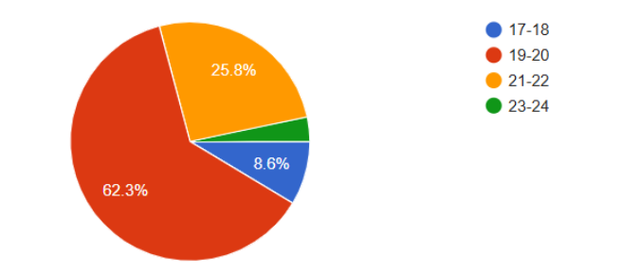
Fig 1.1: pie-chart representing the age groups of respondents.

We draw a histogram which visually represents the age distribution of respondents:

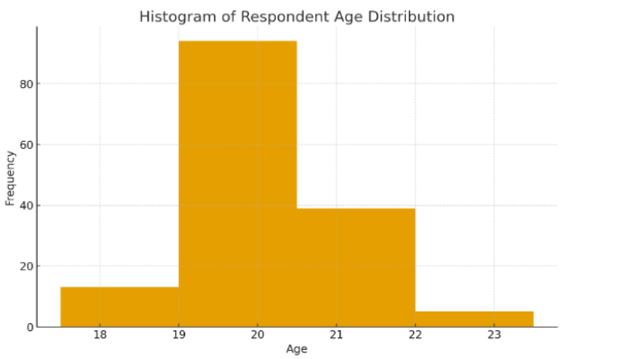

Fig 1.2: Histogram representing the age distribution of respondents:

Now,
Since the data are grouped into age intervals, class midpoints were used to compute mean, median and mod. Thus, using the formula to calculate mean, median and mode we get:
Mean age= 20 years,
Median age=20.3 years and
Modal age =20.2 years.
Also, the histogram in Fig 1.2 shows that distribution is a highly right-skewed and majority is clustered around the 19–20 age group, very few respondents above 22 years.
- Chi-square test for independence of attributes on questions :-
To apply chi-square test of independence of attributes, contingency table is made as:

